For Immediate Release
Media Contact: Susan Keeler, Communications VP
609-924-2770 or communications@jlgp.org

Junior League of Greater Princeton Awards 2007-2008 Grants

The Junior League of Greater Princeton (JLGP) is pleased to announce the recipients of its 2007-2008 Grants. Over the past twelve years the Junior League of Greater Princeton Community Grants Program has awarded almost $120,000 in grants to nearly 80 organizations. All grants are provided to help fund non-profit organizations located in our service area (Bucks (PA), Hunterdon, Mercer, Middlesex, and Somerset counties), which have a one-time need of goods or services for a specific program or purpose related to early childhood education and literacy. The checks were recently awarded to the worthy recipients during the league’s monthly General Membership Meeting (GMM) on Thursday, April 17, 2008 at the Chapin School, in Princeton, NJ.
Bucks County Audubon Society – $2,500
The grant will be used to cover costs of program development, materials and supplies and program delivery of ten sessions for its “Let’s Get Growing” program.

Central New Jersey Council, Boy Scouts of America – $1,500
The grant will help cover costs of materials and supplies (compasses, craft items, ropes, healthy snacks, games, maps, etc.) for the “Scoutreach” camp. This wide-reaching program will serve approximately 500-700 at risk inner city youth ages 1st thru 12th grades.

Princeton Young Achievers – $2,000
The grant will cover the costs of the Literacy Volunteer Coordinator (who will train a team of volunteers), use of an ESL Program Translator, materials and supplies (books and shelving), marketing, and volunteer orientation and assessment for the “Literacy for Life” program.

Catholic Youth Organization CYO) of Mercer County – $1,000
The grant will help cover the costs of books, and cleaning and repair materials at its Trenton Center Preschool, which serves 90 children from single-parent and low- to moderate- income families.

Family & Children’s Services of Central New Jersey – $2,000
The grant will cover the costs of all the educational books and toys required for one year for five low-income/working poor Hispanic families in the East Windsor/Hightstown area. The funds will also help defray related expenses of the Licensed Social Worker, the Program Coordinator, and the Home Visitors in its “Family Child Home Program”.

Family Guidance Center – $1,000
The grant will help cover the cost of purchasing new tables and chairs for the library at its Children’s Day School, a private school for children ages 6-14 who suffer from multiple learning disabilities. The school has 65 students, and average length of enrollment can be from 2 to 3 years.

The Junior League of Greater Princeton is an organization of women committed to promoting voluntarism, developing the potential of women, and improving communities through the effective action and leadership of trained volunteers. The Junior League of Greater Princeton is a recognized leader in the community for developing projects and partnerships that increase the literacy skills of young children and their parents. This has been the focus area for all of their community service activities in the Greater Princeton area since 2004. The Junior League of Greater Princeton is able to support training programs, community projects and a community grants program through fund-raising efforts. Women over the age of 21, committed to voluntarism, regardless of race, religion or national origin are welcome as members. The Junior League of Greater Princeton is part of the Association of Junior Leagues International, which includes 293 Junior Leagues in the United States, Canada, Mexico and Great Britain. For more information please visit www.jlgp.org.

###

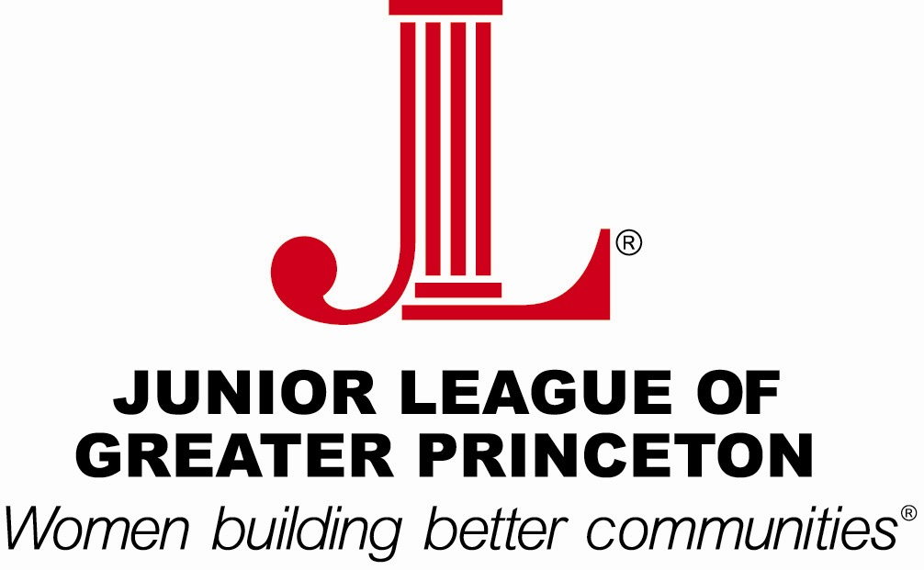


The Junior League of
Greater Princeton is an
organization of women
committed to promoting
voluntarism, developing the potential of women and improving communities
through effective action and leadership of trained volunteers. Its purpose is exclusively educational and charitable.

