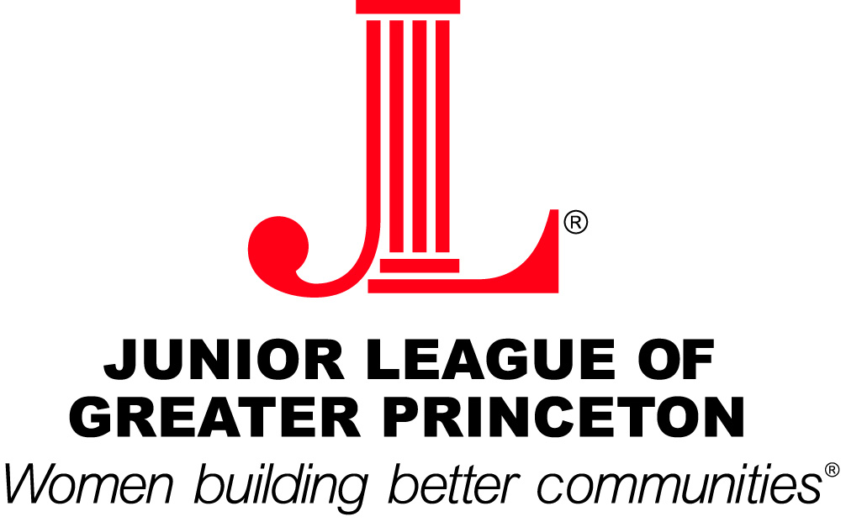

2008-2009 Grant Recipients

- UIH Family Partners for its Discovering Books, Discovering the World project, which will establish two literacy-rich, child-friendly “learning and growing zones” in their New Empowerment Alternatives (NEA) residential program for adolescent mothers and their children
- Bucks County Audubon Society for its interactive Let��®s Get Growing! program, which educates young children in plant growth, food production, the importance of plants in our lives, and healthy food choices through age-appropriate hands-on activities, teaching models, and demonstrations
- Homefront for the purchase of age-appropriate software for use by pre-Kindergarten children and their mothers in its existing computer labs
- The Arts Council of Princeton for an 8-week summer extension of their ArtReach enrichment program in which an art educator from the Arts Council conducts classes in daycare centers to prepare students for kindergarten readiness with multi-stage art projects designed to develop motor skills, creative thinking and group participation
- Womanspace for educational materials for its Home-School Program which provides a schooling option for children who are living in their Emergency Services Shelter, are in a transitional time after fleeing an abusive domestic situation, and are in need of an alternative to public school in order to continue their education while feeling safe
- Princeton Young Achievers for Phase 2 of their Literacy for Life program, which was launched with JLGP funding last year and has since grown quickly. This project provides academic after-school programming to children in grades K-5 who live in three subsidized housing sites in Princeton

