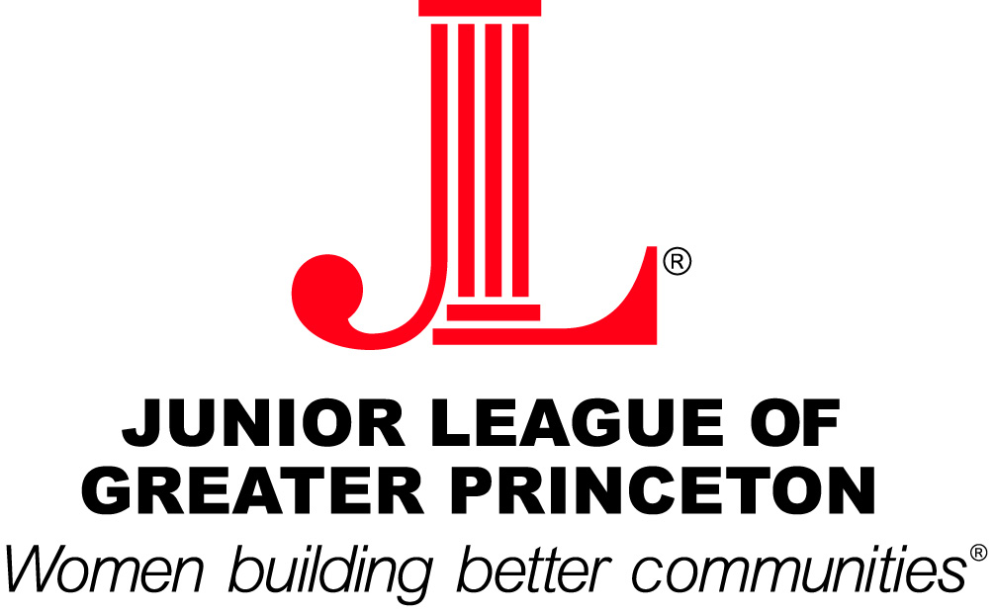

2009-2010 Grant Recipients
Artworks - $1,500
Grant will help support a Youth Arts Education Program, which is a series of 20 advanced Fine Arts classes conducted during after-school hours for Trenton middle-school students. This project is in conjunction with the Boys and Girls Club of Trenton and will provide the children with an outlet for self expression.
Dress for Success Mercer County - $1,000
Grant will be used to purchase of computers, desks, printer and software.
Family Guidance Center - $1,000
Grant will be used to purchase reading-level assessment tools to better serve the students and improve their reading skills.
Tabor Children’s House - $1,500
Grant will fund a Parent-Child Reading Involvement Program, which will help strengthen the reading skills of the pre-school and pre-kindergarten children and increase parental involvement in their child’s education.

