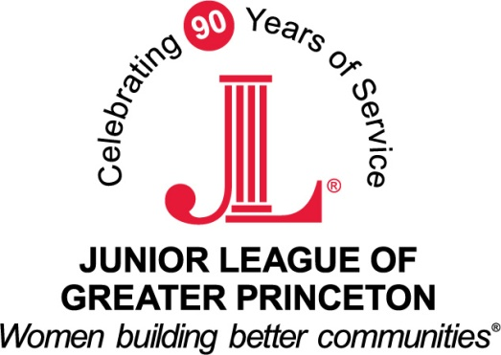
2013-2014 Grant Recipients
Millhill Child & Family Development - $1,500
Millhill Child & Family Development exists to support and empower the Greater Trenton area's most at-risk children and their families. Their mission is to empower children and families through individualized and culturally sensitive educational and behavioral health services, to transform our under-resourced community. The funds will be used to support their “Reading Ready!” Preschool Literacy program by purchasing specific books, games and other supplies.
This program helps to provide a literacy-rich foundation, which would not otherwise be available to the Greater Trenton area's most at-risk children. Millhill’s supply of books and literacy materials is constantly utilized, much loved...and in dire need of replacement and updating. The books needed cover a variety of content areas to get students excited about reading and (for the oldest of them) kindergarten ready. Through this grant, Millhill will be able to provide new books and literacy development materials for the 150 two- through five-year-olds served through Millhill’s NAEYC-accredited early education program. Millhill’s certified early education teachers will utilize specific materials, teaching strategies, and assessment methods based on both the chronological age and developmental readiness of the children in their classes and on each child’s individualized learning plan. Materials will be used on a daily basis for teacher lead, group, and independent activities.
YMCA of Trenton - $1,500
The YMCA is a diverse organization of men, women and children joined together by a shared commitment to nurturing kids, promoting healthy living and fostering a sense of social responsibility. The mission of the YMCA of Trenton is to provide opportunities for all individuals and families by putting values and principles into practice through programs and activities that build a healthy spirit, mind, and body. The funds will be used to support their Super Science Saturdays program, specifically to purchase specimen cups, microscopes, journals, and other supplies as well as help cover staff fees.
Through Super Science Saturdays, the YMCA of Trenton will provide science focused extra-curricular activities to children who reside in the Trenton area. Weekly sessions will engage students in grades 3 to 5 in critical thinking exercises that offer exposure to hands-on experiments. Additionally, through journaling their experiences and results of experiments children will have an opportunity to practice and improve their written communication.
Princeton Senior Resource Center - $1,000
The Princeton Senior Resource Center is a private non-profit organization founded in 1974 to provide programs and services to promote healthy aging for Princeton area older adults (age 55+). The mission of PSRC is to empower older adults in the diverse Princeton community to make informed choices and live healthy lives. PSRC offers affordable services, programs, and opportunities that support, educate and engage older individuals, their families and caregivers. The funds will be used for their Grandpals program, which matches older adult volunteers with kindergarten through second grade children for the entire school year to encourage literacy and a love of learning. The GrandPal volunteers read to the children and encourage their developing reading skills. They also share stories and develop an intergenerational friendship between adults and children who often miss close relationships with their own grandchildren/ grandparents. The grant from the JLGP will be used specifically to purchase books, orientation and newsletter materials; perform background checks; and provide for a volunteer recognition party.
The Crisis Ministry of Mercer County, Inc. - $750
The Crisis Ministry was founded in 1980 by the leadership of Nassau Presbyterian Church and Trinity Episcopal Church in Princeton as a community response to the economic recession of the time. Their mission is partnering with our community to achieve stability for our neighbors in need. The funds will be used towards operating costs for their Harvesting Hope program, which combines work experience with daily training and job search activities.
The program enrolls 60 recipients of public benefits annually and is designed to equip them to qualify for and obtain employment. All trainees who enroll in Harvesting Hope are parents who receive Temporary Aid to Needy Families. Trainees in 2013 have gone on to further education and training, including commercial driver training and employment/positions such as: Macy’s cashier; Trane assembly and manufacturing associate; Trenton Police Department crossing guard; a home improvement installer; a landscaper; a Rite Aid pharmacy technician; McDonald’s; Camp Bow Wow; Head Start preschool assistant; Chipotle; and a variety of positions through area staffing agencies.

