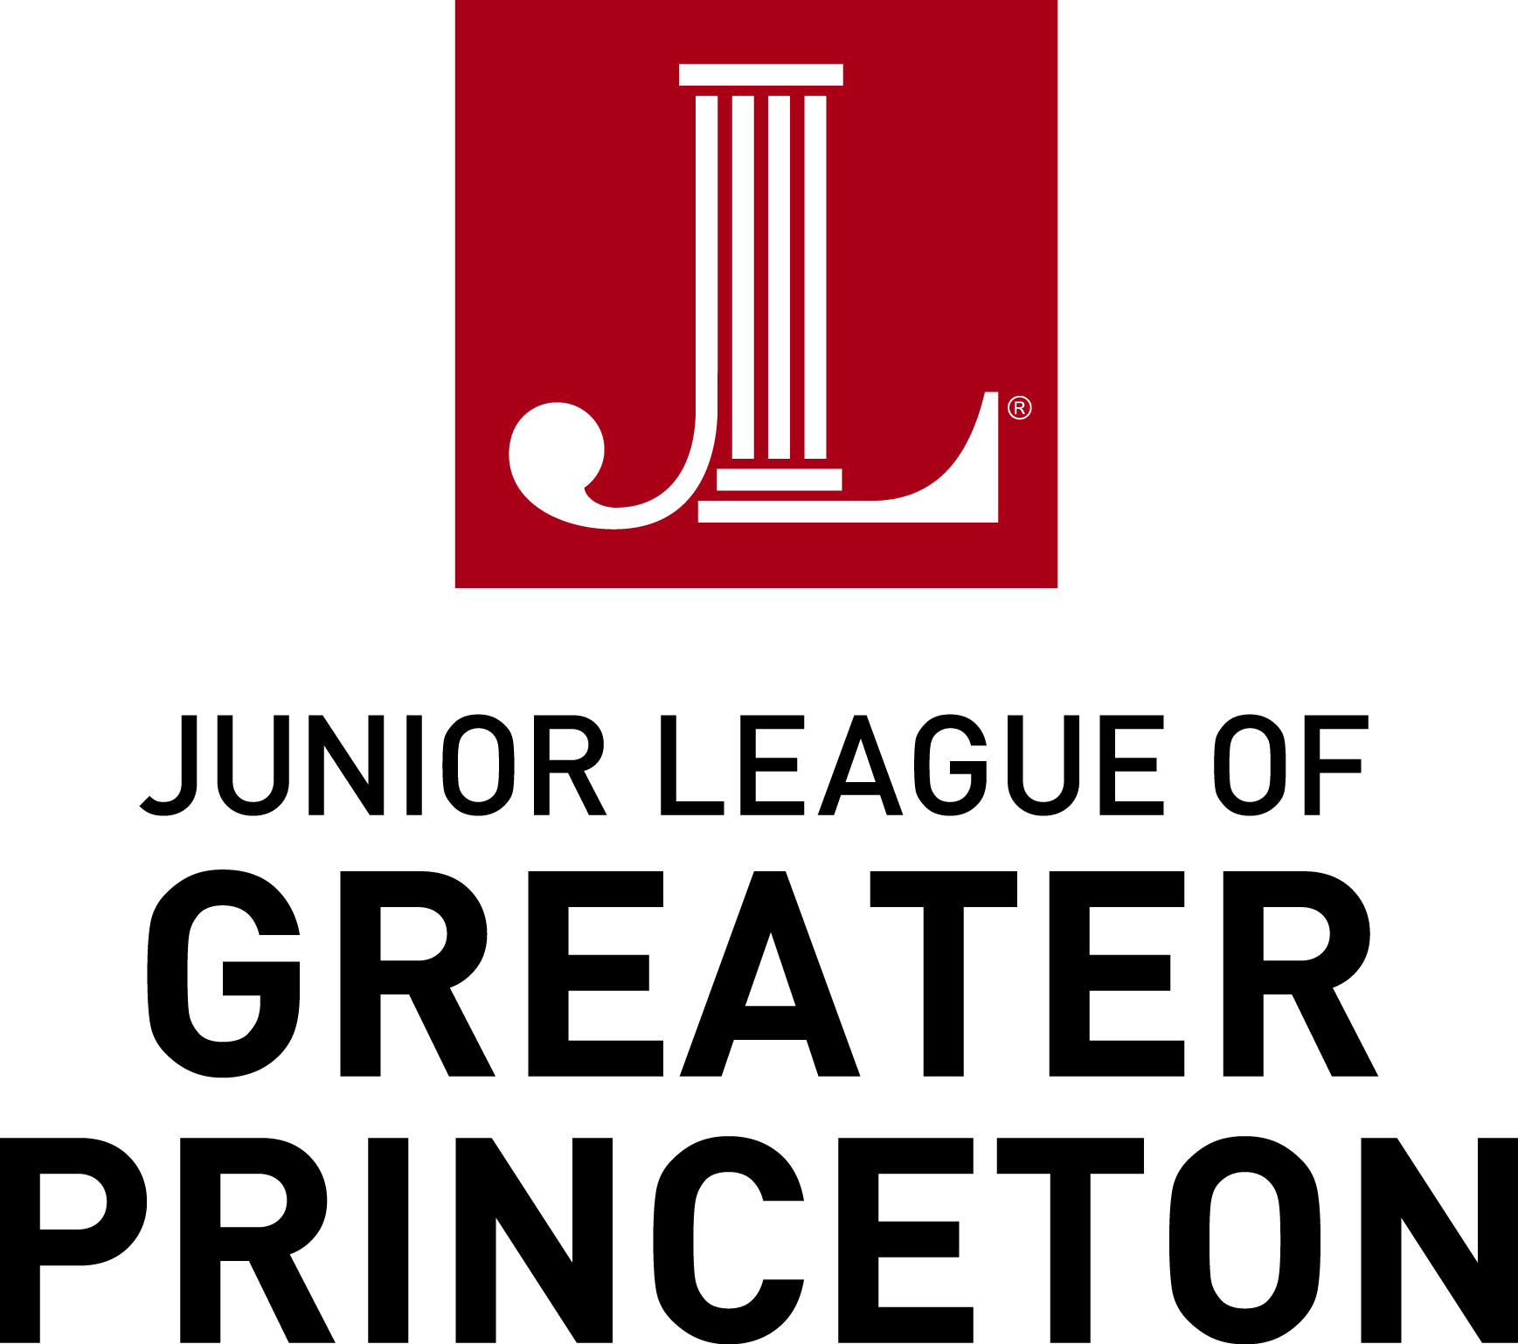

2017 Community Program Grant Application

Amount Requested _____________

Section 1: Contact Information

Name of organization
(If available, please email latest Annual Report)
Mission Statement

_{Date Founded}
Program for which funding is requested

Federal ID &/or Charitable Registration No.
Address
Telephone number
Contact person
Title

Email Address
Website Address
Address (if different)
City/State/Zip
Telephone number (if different)

Are there any Junior League of Greater Princeton members on your Board or involved with your organization?

Section 2: Program Details (as it relates to welfare and empowerment of women and children, including programs focusing on education, health, employment, and science literacy)
^{Project Name}
Project Dates

Project Description
(Attach additional sheet, if needed)

Statement of Need

(Please include detailed budget)

Methods for Implementation: ____________________________________________________________________________________________

____________________________________________________________________________________________________________________

Population (include #) to be served: _______________________________________________________________________________________

__________________________________________________________________________________________________________________

__________________________________________________________________________________________________________________

Manpower required for Project: ______________________________________________________________________________________

______________________________________________________________________________________________________________

Alternative plan for funding if funds are not available from the JLGP: _______________________________________________________

_________________________________________________________________________________________________________________

_________________________________________________________________________________________________________________

How will Program be sustained in future years? ____________________________________________________________________

__________________________________________________________________________________________________

Section 3: Publicity Plan

Do you have a publicity plan for your organization and this project specifically? Will the Junior League of Greater Princeton be included in this plan? If so, please describe: _____________________________________________________________________

___________________________________________________________________________________________________________

____________________________________________________________________________________________________________

____________________________________________________________________________________________________________

How did you hear about the JLGP Community Grants Program? Please select all that apply:

_____ Newspaper article ______ Previous JLGP relationship

_____JLGP website ______ Other website (please specify)
Other (please specify):_____________________________________________________________________________
______________________________________________________________________________________________________________________________________________________________________________________________

Section 4: Leadership
Executive Director/Board Member Name _____________________________________

Title ________________________________________

Date _________________________________________

Signature ____________________________

Grant Application Deadline is January 20, 2017

Please email completed application to:
Deborah Vogel Brown
2016-2017 Grants & Scholarships Chair
grantsandscholarships@ jlgp.org

If you have any questions, please contact Debbie at grantsandscholarships@jlgp.org.

