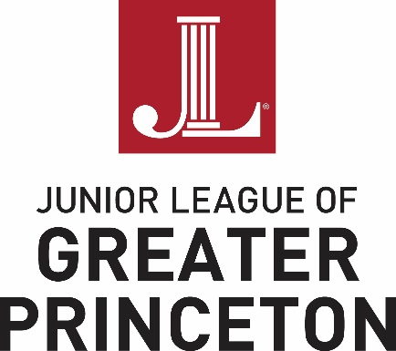

2017-2018 Voluntarism Scholarship Award Instructions

To ensure that your application is reviewed and processed as quickly and accurately as possible, please read the following criteria and procedures.

Criteria for Scholarships

All applicants must:
- Reside in the JLGP service area (Mercer County, NJ, and Bucks County, PA, as well as neighboring portions of Hunterdon, Middlesex, Monmouth, and Somerset Counties in New Jersey)
- Be female
- Be a graduating high school senior entering a post-graduate institution
(four-year, two-year, or vocational school) in the year in which the scholarship application is submitted
- Demonstrate a strong commitment to voluntarism in the local community
- Be advised that financial need and scholastic achievement will not be considered in the evaluation process

Available Awards

Scholarship checks will be written to the school or university on behalf of the scholarship recipient. Students may apply for a scholarship in either of the following two categories:
- $1,000 award for Excellence and Leadership in ongoing volunteer activities
- $1,000 award for Demonstrated Leadership in a single community service volunteer project

Procedures

All applicants must:
- Personally complete the application. (Please indicate the scholarship category for which you are applying at the top of the application).
- Understand that submitting an application is in no way a guarantee that a scholarship will be granted.
- Include one signed recommendation from a volunteer supervisor who knows the applicant personally. This is the only endorsement required. Other endorsements should not be included.
- Submit all attachments, if applicable, with the application. The Junior League of Greater Princeton cannot assume responsibility for items that are received separately. Incomplete applications will not be considered.
- Be advised that only those applications received by February 2, 2018 will be considered. The Junior League of Greater Princeton is not responsible for lost or misdirected applications. Faxes will NOT be accepted for consideration.
- Understand that scholarship award checks will be written to the school or university on behalf of the scholarship recipient. The Junior League of Greater Princeton will not be involved with the distribution of funds other than payment to the recipient’s school.
- Be advised that all applications become the property of The Junior League of Greater Princeton and will not be returned to the applicant. All information will be treated in a professional manner. The selection committee will inform all applicants of its decision no later than March 15, 2018 via email or regular U.S. mail.
- Direct all questions to Alexia Burnett Salinas, 2017-2018 Grants and Scholarship Chair at grantsandscholarships@jlgp.org.

