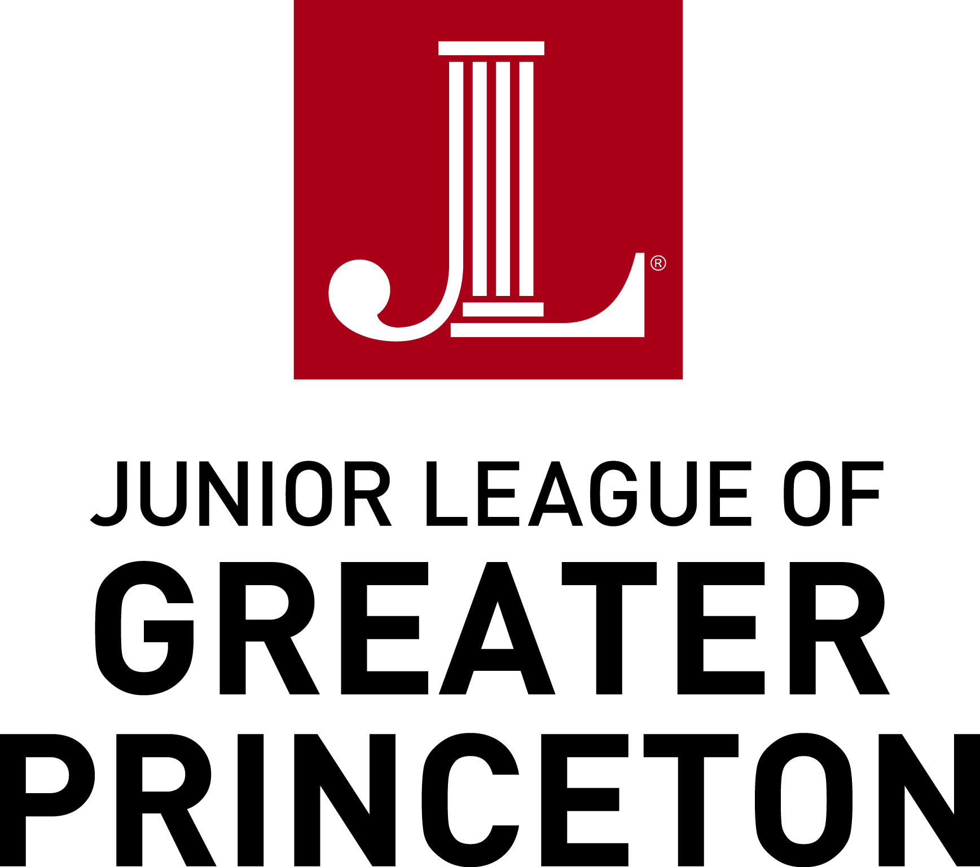

2020 Community Program Grant Application

Amount Requested

Section 1: Contact Information
Name of organization
(If available, please email latest Annual Report)
Mission Statement
Date Founded
Program for which funding is requested
Federal ID &/or Charitable Registration No.
Address

Telephone Number
Website Address
Contact Person/Title/email
Address (if different than above)
Telephone number

Are there any Junior League of Greater Princeton members on your Board or involved with your organization?

Section 2: Program Details (as it relates to welfare and empowerment of women and children, including programs focusing on education, health, employment, and science literacy)
Project Name

Project Dates

Project Description (Attach additional sheet, if needed)

Statement of Need (Please include detailed budget)

Methods for Implementation:

Population (include #) to be served:

Manpower required for Project:

Alternative plan for funding if funds are not available from the JLGP:

How will Program be sustained in future years?

Section 3: Publicity Plan

Do you have a publicity plan for your organization and this project specifically? Will the Junior League of Greater Princeton be included in this plan? If so, please describe:

How did you hear about the JLGP Community Grants Program? Please select all that apply:

_____ Newspaper article ______ Previous JLGP relationship

_____JLGP website ______ Other website (please specify)
Other (please specify):

Section 4: Leadership
Executive Director/ Member Name
Title
Date
Signature

Grant Application Deadline is January 31, 2020

Please email completed application to:
Nancy Mellos
2019 - 2020 Grants & Scholarships Chair
grantsandscholarships@ jlgp.org

If you have any questions, please contact Nancy at grantsandscholarships@jlgp.org.

