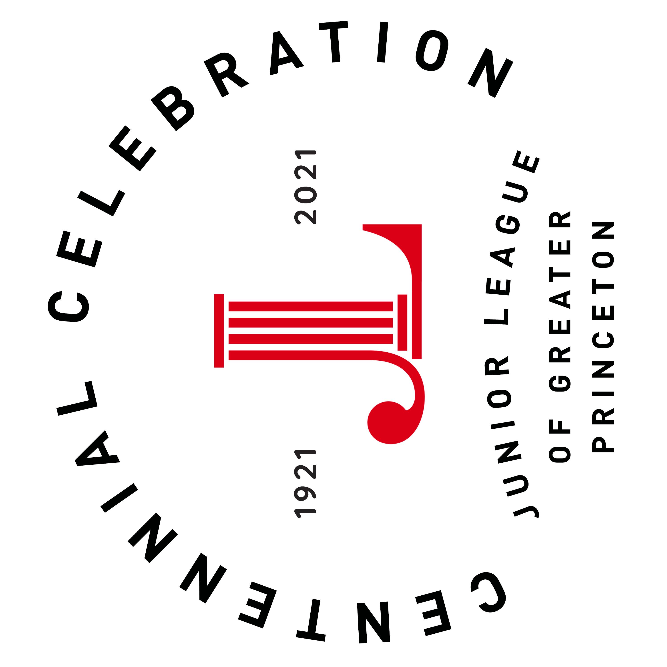
The Junior League of Greater Princeton (JLGP) will celebrate its 100th anniversary of service to our community in 2021. The JLGP Centennial Celebration will highlight our past projects, our volunteers and it will look toward the future and what the next 100 years will bring.

The JLGP invites you to participate in the journey that has defined our legacy. In addition to our ongoing community projects, the League is implementing a special Centennial Project to mark this milestone. Through a Request for Proposal (RFP) process, the JLGP will award $25,000 to one (1) organization to implement a community-based project with a focus on Food Security. This project will be implemented from June 1, 2021 to May 31, 2022. The JLGP has recently selected Food Security as its focus area for community work, proposals must address this as the main issue.

The applicant should include ample opportunities for JLGP members to volunteer and raise awareness of both JLGP’s mission and our community partner(s). The JLGP service area is Mercer County, NJ and
Bucks County, PA.

If your organization would like to apply for this RFP, complete the application below.

Letter of Intent Due: January 30, 2021
Application Due: February 28, 2021

Applicant Information

Organization Name:

Mission Statement:

Date Founded:

Service Area: ____Mercer County, NJ ____Bucks County, PA (please check the location served)

Address:

Telephone Number:

Website Address:

Federal ID and/or Charitable Registration No:

Contact Person & Title (for questions related to this submission, include email address):

Executive Director Name & Length of Time in Position:

Are there any Junior League of Greater Princeton members on your Board or involved with your organization?: ____Yes _____No

Has your organization previously received grant funds from the JLGP? ___Yes ___No

Project Summary (Project focus must be Food Security)

Project Name:

Project Start and End Date:

Project Description:

Application

Statement of Need (10 Points):

Goals & Objectives (10 Points):

Methods (25 Points) (Please include the names of any other organizations you will partner with to implement this work):

Measurable Outcomes (20 Points):
(Please address how this project will impact the intended participants, what the measurable outcomes wilsh accomplish)

Volunteer Opportunities for JLGP Members (5 Points):

Sustainability (10 Points):
(How will this project continue after the JLGP funding cycle is complete?)

Publicity Plan (10 Points):
(Include how the JLGP will be included in the publicity plan)

Budget (10 Points):
(Please attach budget as separate attachment, include other sources of funding that will be leveraged for this project. Please include most recent 990 form as an attachment to the application.)

Governance Information:
Please attach a list of the Board of Trustees (include their board titles and terms). How does the Board demonstrate its commitment to the organization (financial support, talent and /or in-kind support)?
Percentage of your Board that made a personal donation to your organization last year? If your Board did not have 100% giving last year, please address.

Response to Covid-19:
Please indicate how your agency has had to shift operations/service delivery etc in response to Covid-19 and any potential challenges to implementing the proposed project due to Covid-19.

Required Documents:
- Letter of Intent (Due January 30, 2021)
- Application (you may type directly in this form, please save as PDF file for submission)
- Budget
- Annual Report
- Board of Trustees Listing
- 990 Form

Grant Award & Payment Schedule
Grant Award: June 1, 2021
Grant Period: June 1, 2021 – May 31, 2022
Total Grant Award: $25,000
Funds will be dispersed as follows:
June 1, 2021 | $15,000 (60%)
October 1, 2021 | $7,500 (30%)
February 1, 2022 | $2,500 (10%)
*Progress reports due September 1, 2021 and February 1, 2022 – JLGP will provide document
*If a different schedule is required, please note that in the “Budget” section of the grant application.

Letters of Intent are required for grant to be reviewed
Letter of Intent due January 30, 2021

Applications are due on February 28, 2021
Please submit items 2-6 as the grant application electronically to rfp@jlgp.org
Questions may be directed to Michelle Emerson
and Christina Bailey at the email noted above.

**The JLGP reserves the right to schedule a site visit with applicant agency**

